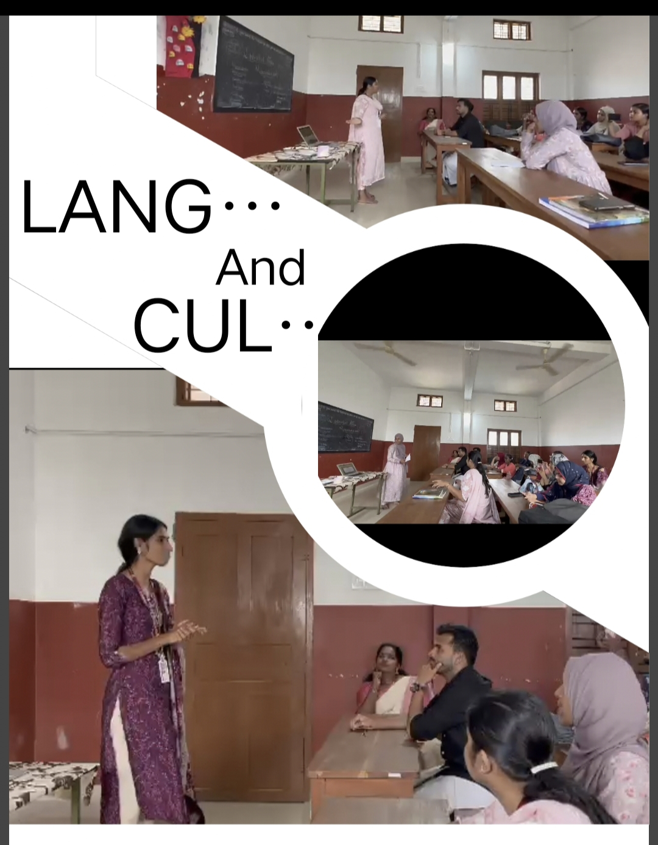

CELEBRATION OF BHARATIYA BHASA UTSAV

A lecture on ‘ Language and Multiculturalism ’ organized by First year English Department B – batch students in accordance with Celebration of Bharatiya Bhasa Utsav ( BBU) for all Teacher Education Institutions ( TELs), an initiative of Government of India, NCTE's endeavors to conduct programmes to promote language learning through the use of regional languages and technology. The lectures were delivered by Teena Varghese, Naseeha Abdul Nasir and Shaija Franscis. It was really enlightening for the students. The lectures were aimed to explore the dynamic relationship between language and multiculturalism and it was an excellent success.

